v1.

Model name :- Electric Optima HX

Company:- Hero

Price :- 56,000 Rs (avg. showroom price )

Speed :- 42 Km/hr

Range:- 82 Km/c

Type :- Electric

Battery Capacity :- 51.2V / 30AH

Full charge :- 4 to 5 hr

Colours :- Grey , Blue , White

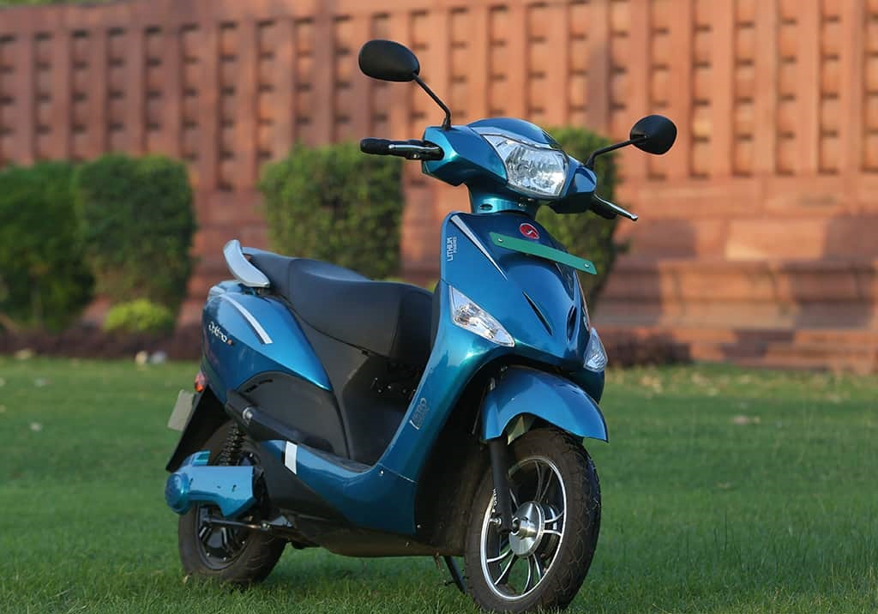

<https://heroelectric.in/bike/optima-hx-single-battery/>

v2.

Model name :- Pleasure plus

Company:- Hero

Price :- 63,000 Rs (avg. showroom price )

Engine Capacity:- 110.9 cc

Mileage :- 50 kmpl

Kerb Weight :- 104 kg

Seat Height :- 765 mm

Fuel Tank Capacity :- 4.8 litres

Max Power :- 8 bhp

Colours :- sporty black , Matt Red ,Matt Green ,

Pearl Silver White ,polestar Blue

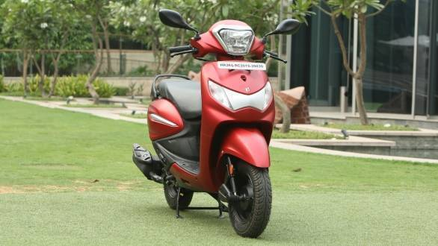

<https://www.bikewale.com/hero-bikes/pleasure-plus/>

V3.

Model name :- Hero Electric Dash

Company:- Hero

Price :- 65,200 Rs (avg. showroom price )

Speed :- 25 Km/hr

Range:- 60 Km/c

Type :- Electric

Battery Capacity :- 1.344 KWH

Full charge :- 4 to 5 hr

Colours:- Red

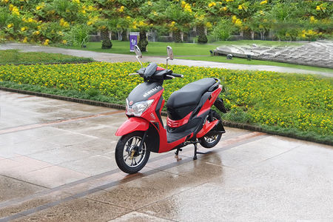

<https://www.bikewale.com/hero-bikes/splendor-plus/colours/firefly-golden/>

v4.

Model name :- Activa 6G

Company:- Honda

Price :- 70,350 Rs (avg. showroom price )

Engine Capacity:- 109.51 cc

Mileage:- 50 kmpl

Kerb Weight:- 107 kg

Seat Height:- 692 mm

Fuel Tank Capacity:- 5.3 litres

Max Power:- 7.68 bhp

Colours :- pearl night star Black , Metallic Blue

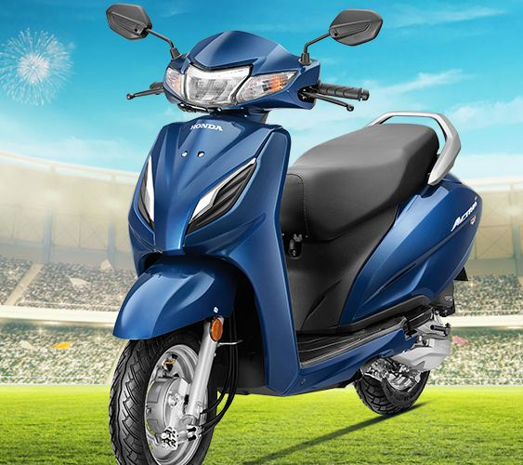

<https://www.bikewale.com/honda-bikes/activa-6g/>

v5.

Model name :- Honda Shine

Company:- Honda

Price :- 74,000 Rs (avg. showroom price )

Engine Capacity:- 124 cc

Mileage:- 55 kmpl

Transmission:- 5 Speed Manual

Kerb Weight:- 114 kg

Fuel Tank Capacity:- 10.5 litres

Seat Height:- 791 mm

Colours :- Black , Geny grey , Rebel Red

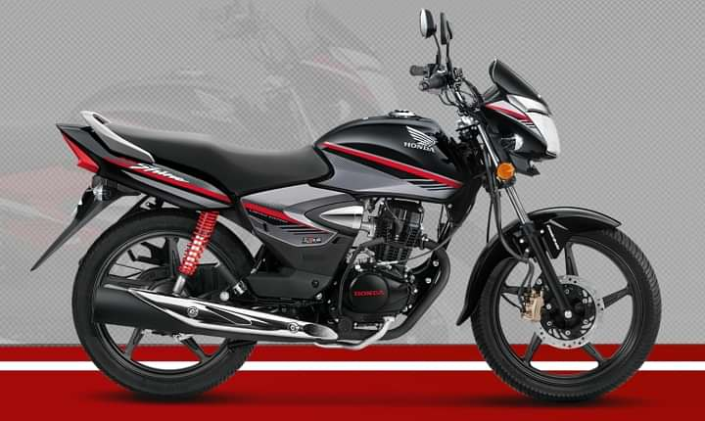

v6.

Model name :- Hero Electric Photon

Company:- Hero

Price :- 74,500 Rs (avg. showroom price )

Speed :- 45 Km/hr

Range:- 108 Km/c

Type :- Electric

Battery Capacity :- 1.8KV

Full charge :- 4 to 5 hr

Color :- Red , Blue , White ,Silver ,Black

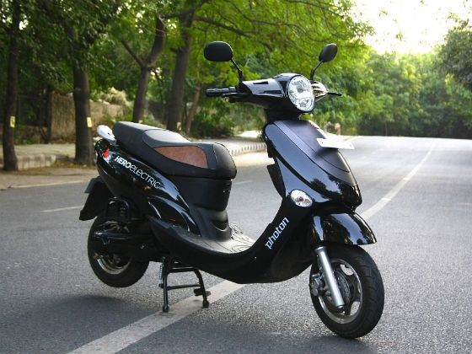

v7.

Model name :- Activa 125

Company:- Honda

Price :- 75,000 Rs (avg. showroom price )

Engine Capacity:- 124 cc

Mileage:- 47 kmpl

Kerb Weight:- 111 kg

Seat Height:- 712 mm

Fuel Tank Capacity:- 5.3 litres

Max Power:- 8.18 bhp

Colours:- Red , White , Blue , Grey , Silver

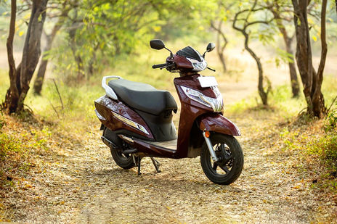

v8.

Model name :- Access 125

Company:- Suzuki

Price :- 75,000 Rs (avg. showroom price )

Engine Capacity:- 124 cc

Mileage:- 50 kmpl

Kerb Weight:- 104 kg

Seat Height:- 773 mm

Fuel Tank Capacity:- 5 litres

Max Power:- 8.6 bhp

Colours:- Black , Bronze , White , Blue , Dark Blue,Red

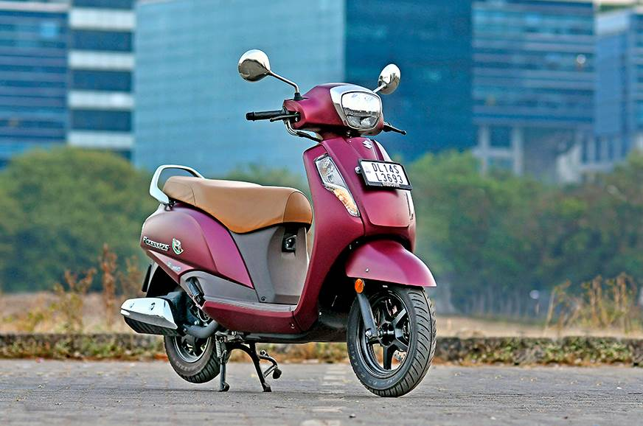

v9.

Model name :- TVS Jupiter Classic ET - FI

Company:- TVS Motor

Price :- 80,000 Rs (avg. showroom price )

Engine Capacity :- 109.7 cc

Mileage:- 50 kmpl

Kerb Weight:- 107 kg

Seat Height:- 765 mm

Fuel Tank Capacity:- 6 litres

Max Power:- 7.37 bhp

Colours:- Indi Blue , Sunlight Ivory , Autumn Brown

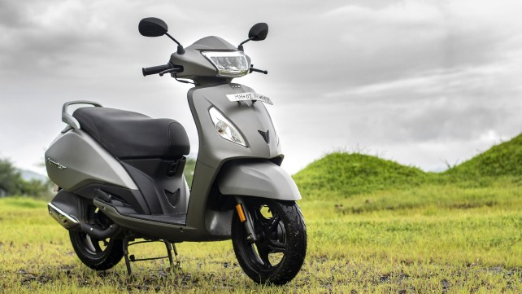

v10.

Model name :- TVS Rider 125

Company:- TVS Motor

Price :- 81,000 Rs (avg. showroom price )

Engine Capacity:- 124.8 cc

Mileage:- 60 kmpl

Transmission:- 5 Speed Manual

Kerb Weight:- 123 kg

Fuel Tank Capacity:- 10 litres

Seat Height:- 780 mm

Colours :- Yellow , Red , Blue , Black

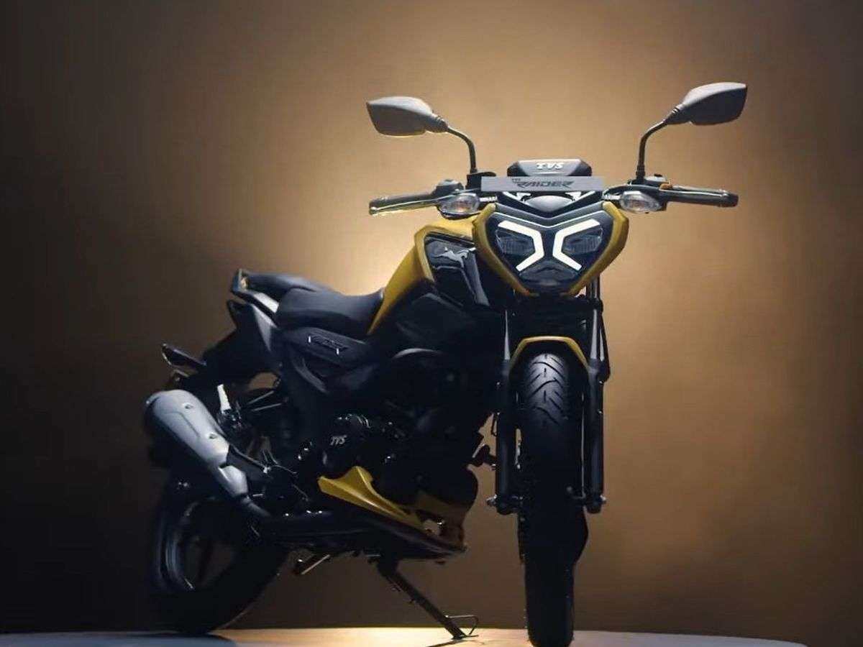

v11.

Model name :- Honda Unicorn

Company:- Honda

Price :- 1,00,200 Rs (avg. showroom price )

Engine Capacity:- 162.7 cc

Mileage:- 50 kmpl

Transmission:- 5 Speed Manual

Kerb Weight:- 140 kg

Fuel Tank Capacity:- 13 litres

Seat Height:- 798 mm

Colours :- Grey , Red , Black

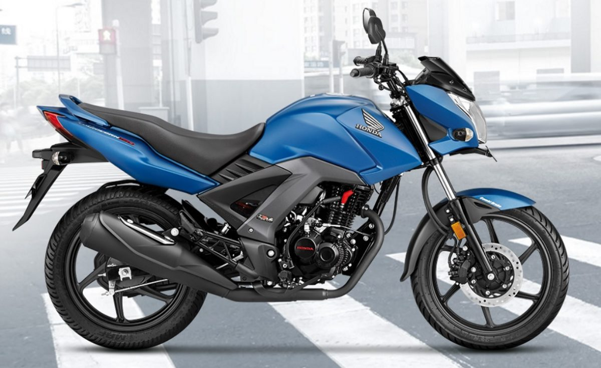

v12.

Model name :- TVS iQube Electric

Company:- TVS Motor

Price :- 1,00,800 Rs (avg. showroom price )

Speed :- 78 Km/hr

Range:- 75 Km/c

Type :- Electric

Battery Capacity :- 2.25KWH

Full charge :- 5 hr

Colours :- White

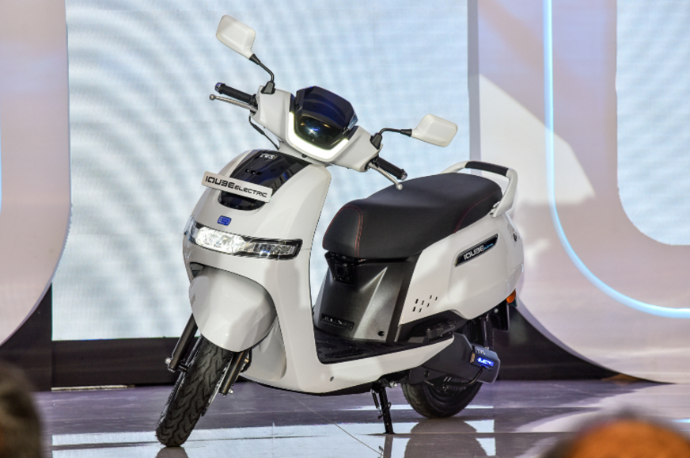

v13.

Model name :- Bajaj Pulsar NS200

Company:- Bajaj

Price :- 1,35,000 Rs (avg. showroom price )

Engine Capacity:- 199.5 cc

Mileage:- 35 kmpl

Transmission:- 6 Speed Manual

Kerb Weight:- 156 kg

Fuel Tank Capacity:- 12 litres

Max Power:- 24.13 bhp

Colours :- White , Red , Blue , Grey

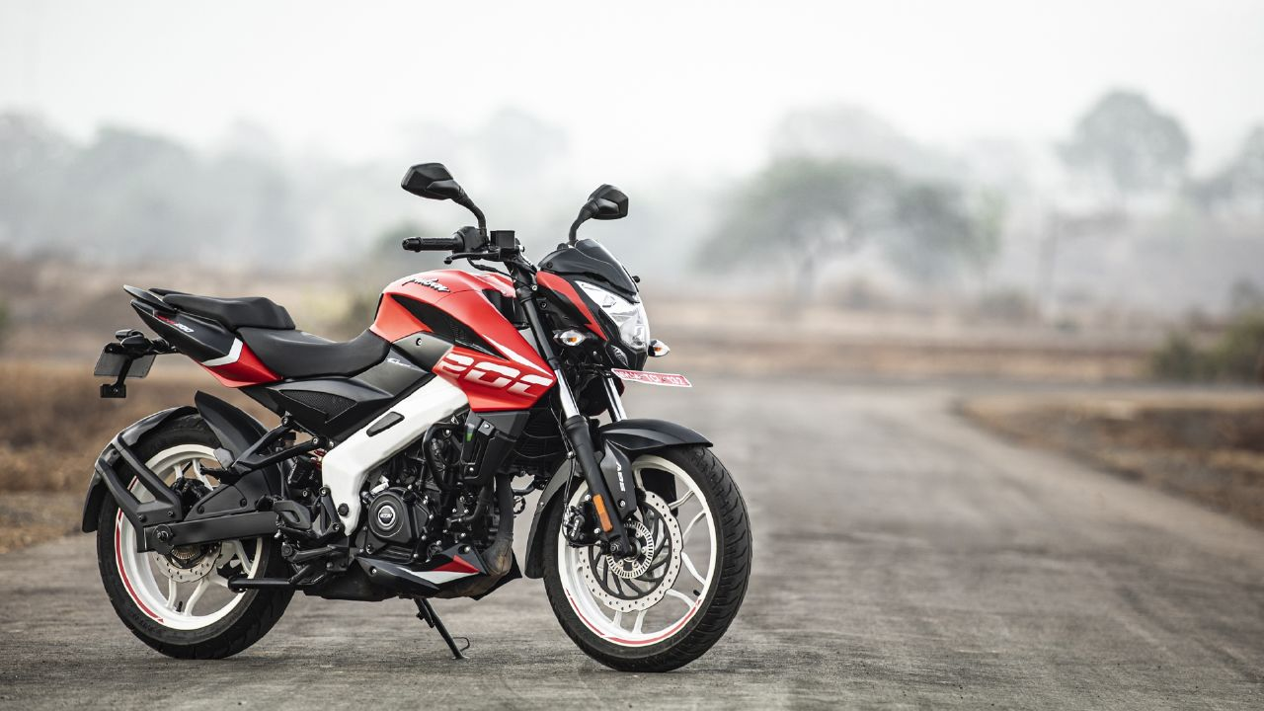

v14.

Model name :- Bajaj Avenger Cruise 220

Company:- Bajaj

Price :- 1,35,000 Rs (avg. showroom price )

Engine Capacity:- 220 cc

Mileage:- 38 kmpl

Transmission:- 5 Speed Manual

Kerb Weight:- 163 kg

Fuel Tank Capacity:- 13 litres

Seat Height:- 737 mm

Colours :- White , Black

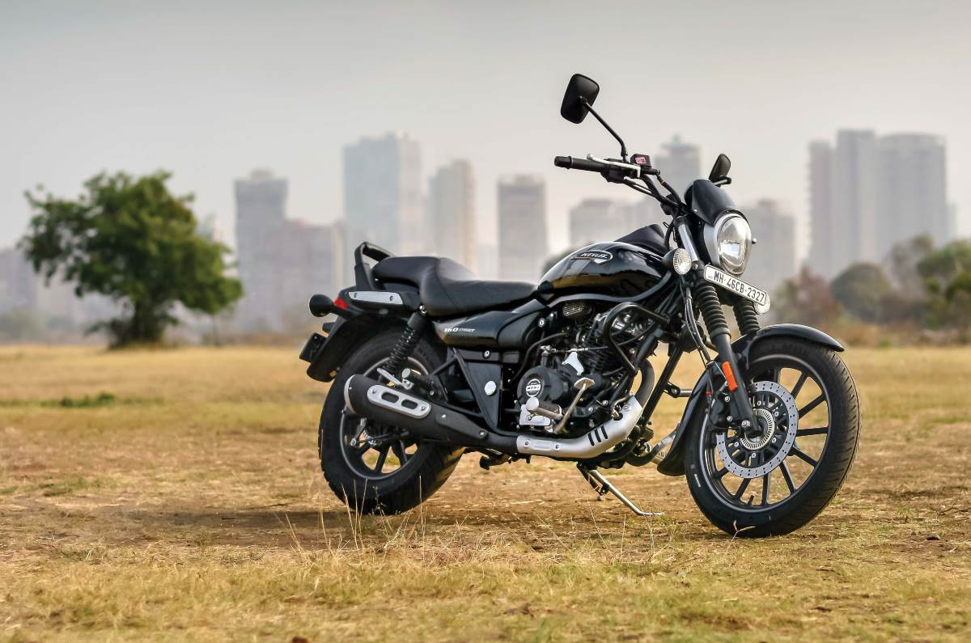

v15.

Model name :- Royal Enfield Bullet 350

Company:- Royal Enfield

Price :- 1,40,000 Rs (avg. showroom price )

Engine Capacity:- 346 cc

Mileage:- 37 kmpl

Transmission:- 5 Speed Manual

Kerb Weight:- 186 kg

Fuel Tank Capacity:- 13.5 litres

Seat Height:- 800 mm

Colours :- Silver , Red , Blue , Black

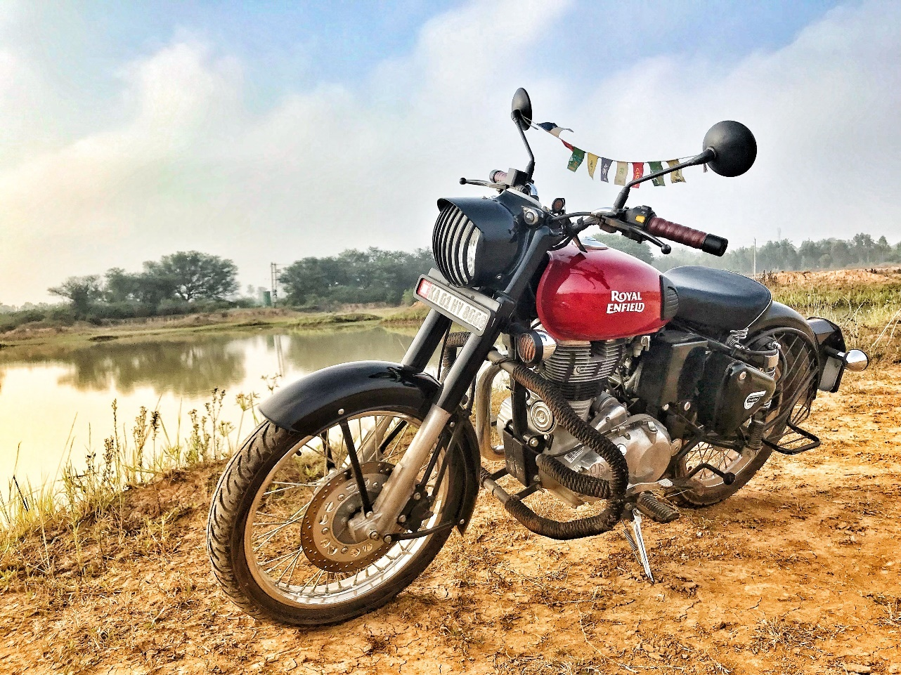

v16.

Model name :- Yamaha YZF R15 V4

Company:- Yamaha

Price :- 1,72,000 Rs (avg. showroom price )

Engine Capacity :- 155 cc

Mileage :- 45 kmpl

Transmission:- 6 Speed Manual

Kerb Weight:- 142 kg

Fuel Tank Capacity:- 11 litres

Seat Height:- 815 mm

Colours :- Red , Blue , Black

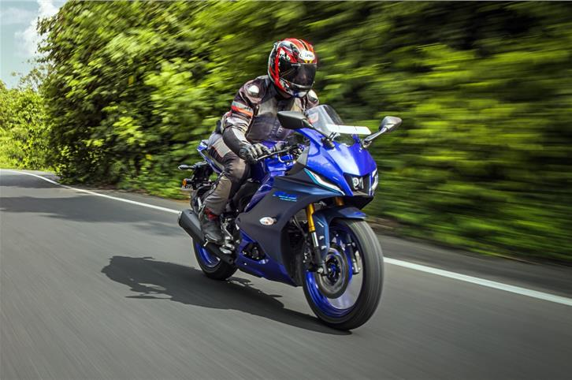

v17.

Model name :- Suzuki Gixxer SF 250

Company:- Suzuki

Price :- 1,82,000 Rs (avg. showroom price )

Engine Capacity:- 249 cc

Mileage:- 35 kmpl

Transmission:- 6 Speed Manual

Kerb Weight:- 161 kg

Fuel Tank Capacity:- 12 litres

Seat Height:- 800 mm

Colours :- Blue , Black

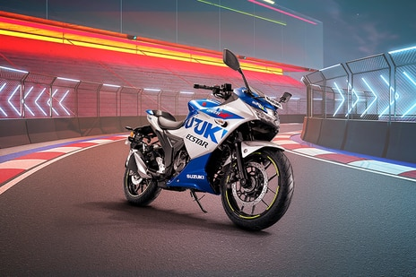

v18.

Model name :- Royal Enfield Meteor 350

Company:- Royal Enfield

Price :- 1,98,500 Rs (avg. showroom price )

Engine Capacity:- 349 cc

Mileage:- 35 kmpl

Transmission:- 5 Speed Manual

Kerb Weight:- 191 kg

Fuel Tank Capacity:- 15 litres

Seat Height:- 765 mm

Colours :- Yellow , Red , Blue , Black

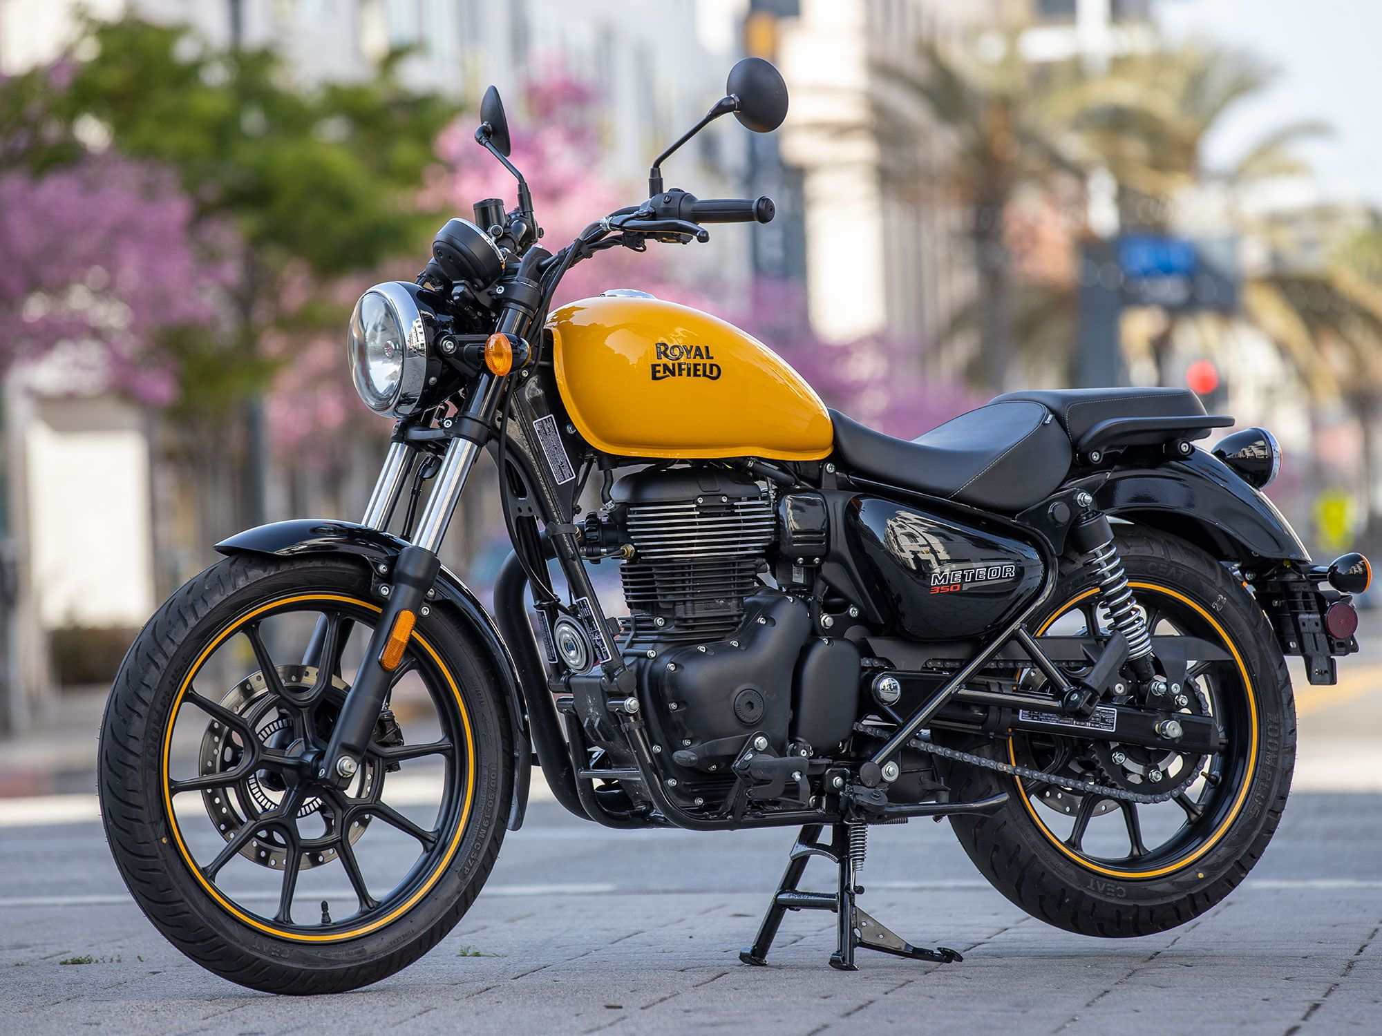

v19.

Model name :- Bajaj Dominar 400

Company:- Bajaj

Price :- 2,07,000 Rs (avg. showroom price )

Engine Capacity:- 373.27 cc

Mileage:- 28 kmpl

Transmission:- 6 Speed Manual

Kerb Weight:- 187 kg

Fuel Tank Capacity:- 13 litres

Seat Height:- 800 mm

Colours :- Green , Black

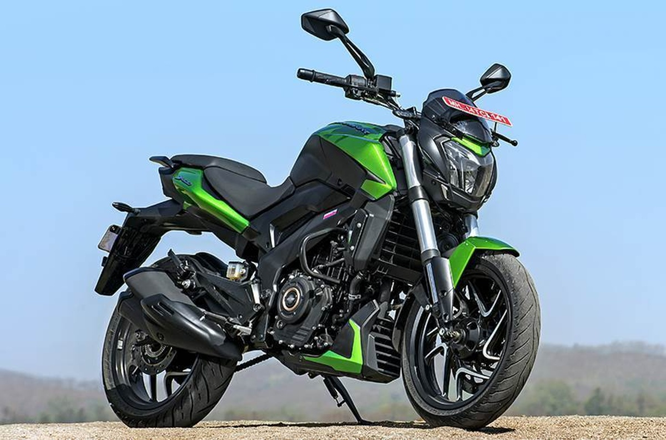

V20.

Model name :- Royal Enfield Himalayan

Company:- Royal Enfield

Price :- 2,10,000 Rs (avg. showroom price )

Engine Capacity :- 411 cc

Mileage :- 30 kmpl

Transmission:- 5 Speed Manual

Kerb Weight:- 199 kg

Fuel Tank Capacity:- 15 litres

Seat Height:- 800 mm

Colours :- Green, Yellow , Red , Blue , Black

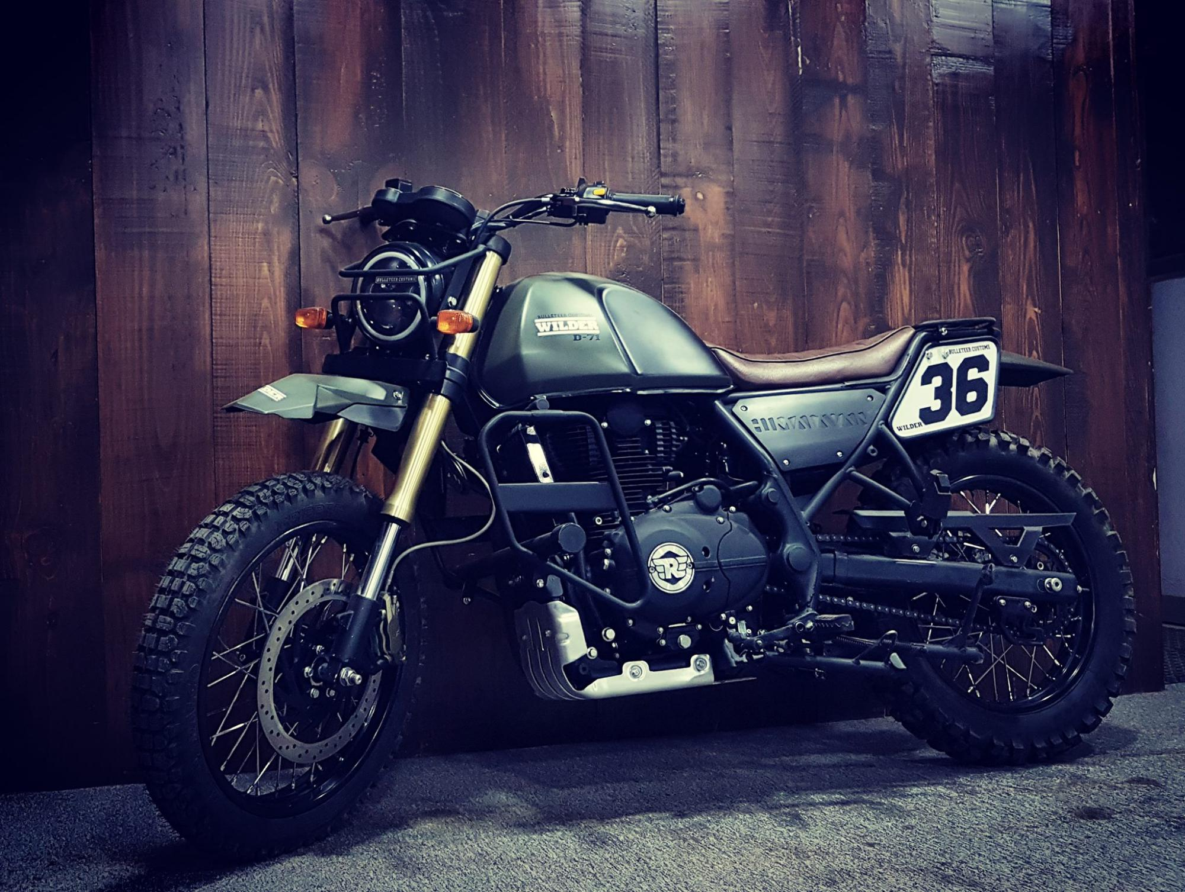

v21.

Model name :- Maruti Suzuki Alto

Company:- Maruti

Price:- ₹ 3.15 Lakh (avg. showroom price )

Mileage:- 22.05 to 31.59 km/kg

Engine:- 796 cc

Transmission:- Manual

Fuel Type:- Petrol & CNG

Seating Capacity:- 4 & 5 Seater

ARAI Mileage:- 31.59 km/kg ( CNG )

22.05 kmpl ( Petrol )

Colours :- White , Red , Blue , Black , Grey

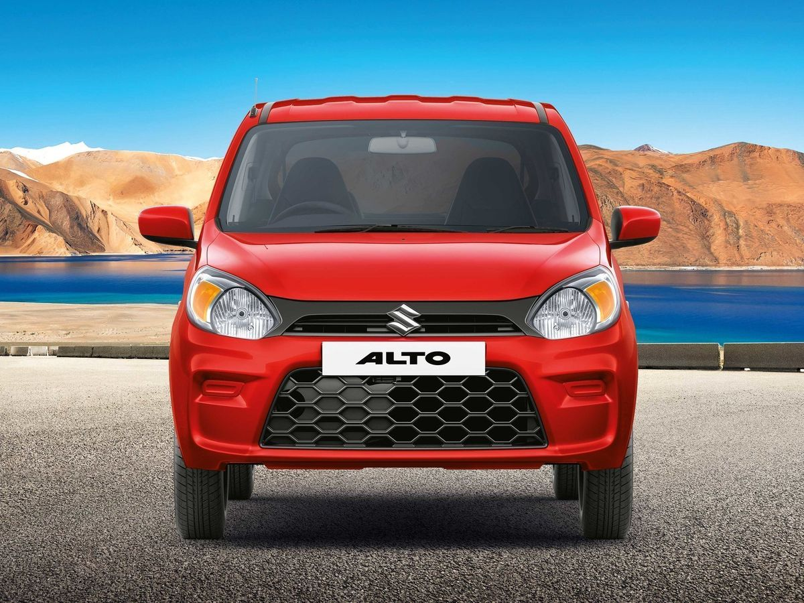

v22.

Model name :- Maruti Suzuki S-Presso

Company:- Maruti

Price:- ₹ 3.78 Lakh (avg. showroom price )

Mileage:- 21.53 to 31.19 km/kg

Engine:- 998 cc

Transmission:- Manual & AMT

Fuel Type:- Petrol & CNG

Seating Capacity:- 4 & 5 Seater

ARAI Mileage:- 31.19 km/kg ( CNG )

21.53 kmpl ( Petrol )

Colours :- White , Red , Blue , Black , Grey

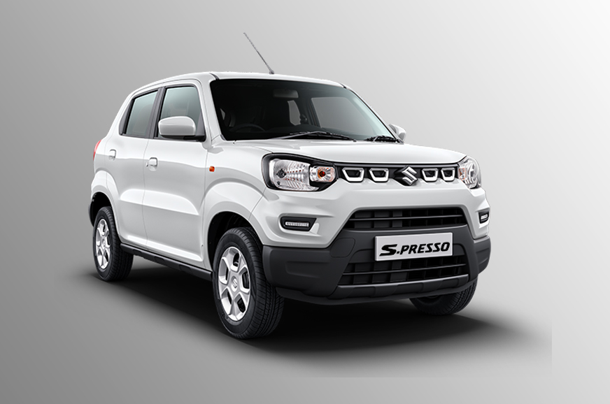

v23.

Model name :- Datsun redi-GO

Company:- Datsun

Price:- ₹ 3.98 Lakh (avg. showroom price )

Mileage:- 20.71 to 22 kmpl

Engine:- 799 to 999 cc

Transmission:- Manual & AMT

Fuel Type:- Petrol

Seating Capacity:- 5 Seater

ARAI Mileage:- 21.07 kmpl ( Petrol )

Colours :- White , Red , Blue , Black , Grey

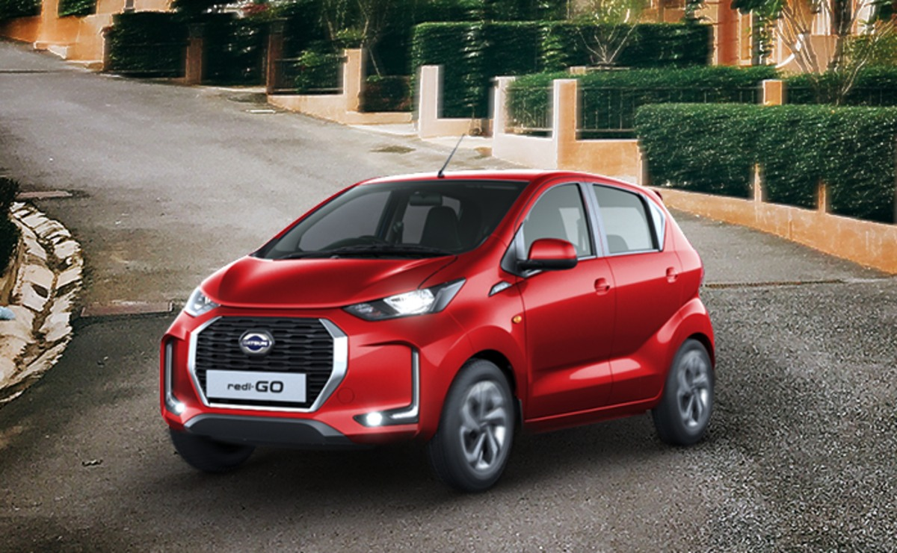

v24.

Model name :- Renault Kwid

Company:- Renault

Price:- ₹ 4.11 Lakh (avg. showroom price )

Mileage:- 20.71 to 22 kmpl

Engine:- 799 to 999 cc

Transmission:- Manual & AMT

Fuel Type:- Petrol

Seating Capacity:- 5 Seater

ARAI Mileage:- 21.07 kmpl ( Petrol )

Colours :- White , Red , Blue , Black , Grey

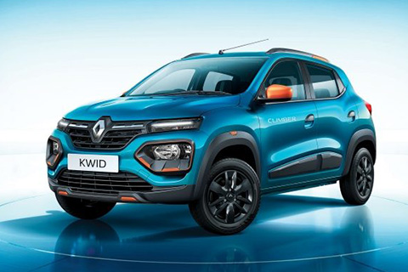

v25.

Model name :- Datsun GO+

Company:- Datsun

Price:- ₹ 4.26 Lakh (avg. showroom price )

Mileage:- 18.57 to 19.02 kmpl

Engine:- 1198 cc

Transmission:- Manual & Automatic (CVT)

Fuel Type:- Petrol

Seating Capacity:- 7 Seater

ARAI Mileage:- 19.02 kmpl ( Petrol )

Colours :- White , Red , Blue , Black , Grey

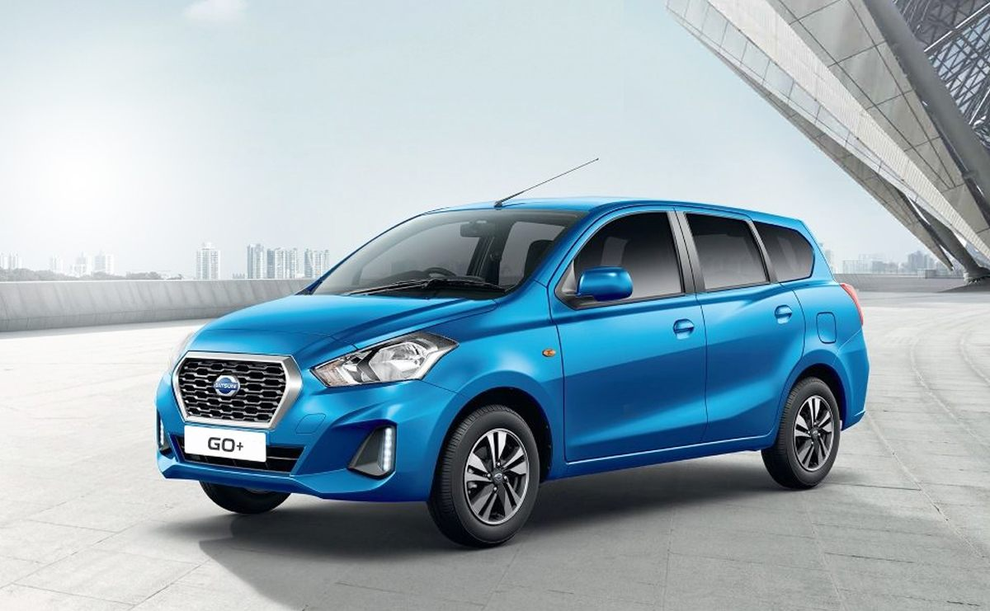

v26.

Model name :- Maruti Suzuki Wagon R

Company:- Maruti

Price:- ₹ 4.93 Lakh (avg. showroom price )

Mileage:- 20.52 to 32.52 kmpl

Engine:- 998 to 1197 cc

Transmission:- Manual & AMT

Fuel Type:- Petrol & CNG

Seating Capacity:- 5 Seater

ARAI Mileage:- 33.52 km/kg ( CNG )

21.79 kmpl ( Petrol )

Colours :- White , Orange, Blue , Black , Grey

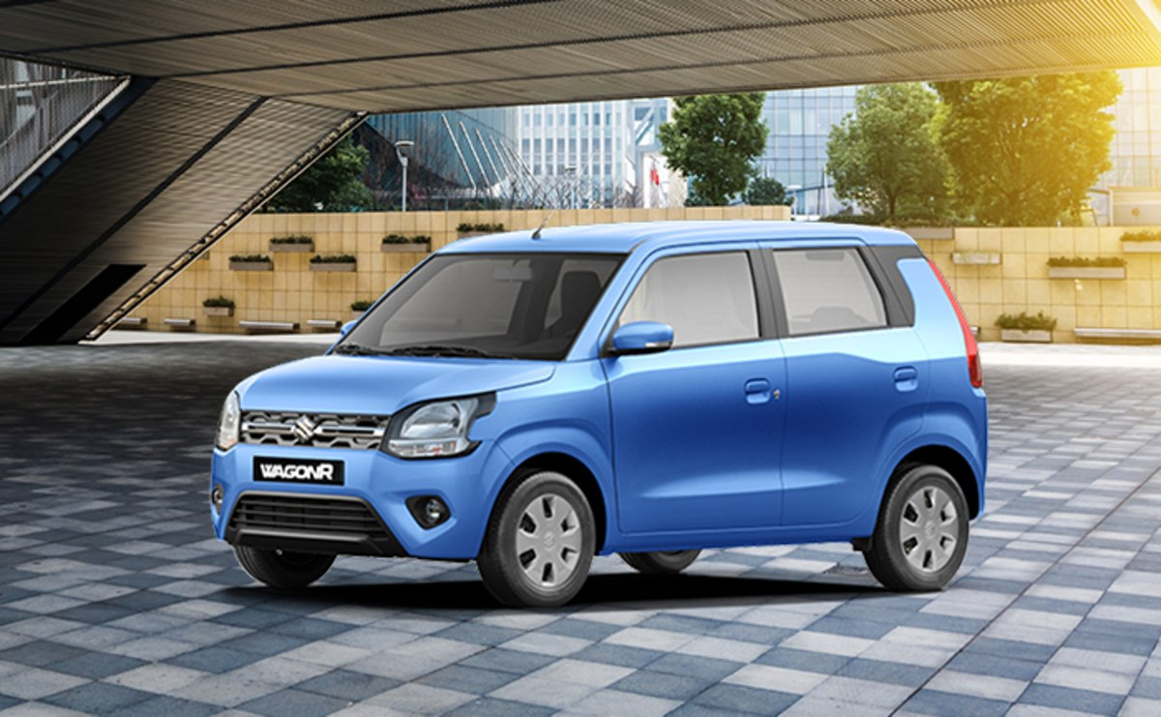

v27.

Model name :- Tata Tiago

Company:- Tata

Price:- ₹ 5.00 Lakh (avg. showroom price )

Mileage:- 19.8 to 23.84 kmpl

Engine:- 1199 cc

Transmission:- Manual & AMT

Fuel Type:- Petrol

Seating Capacity:- 5 Seater

ARAI Mileage:- 19.07 kmpl ( Petrol )

Colours :- White , Red , Blue , Black , Grey

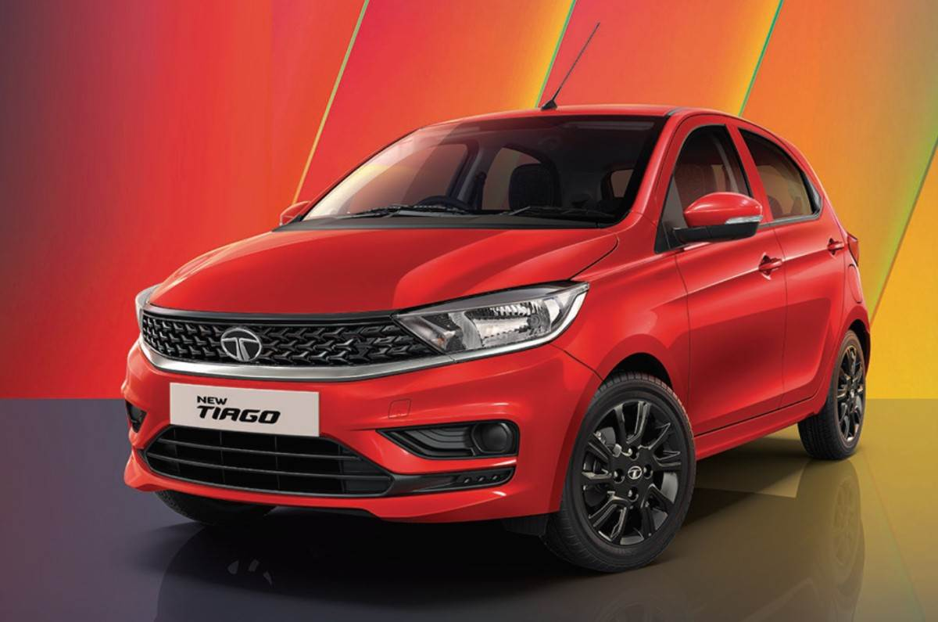

v28.

Model name :- Renault Kiger

Company:- Renault

Price:- ₹ 5.64 Lakh (avg. showroom price )

Mileage:- 19.03 to 20.53 kmpl

Engine:- 999 cc

Transmission:- Manual, AMT & Automatic (CVT)

Fuel Type:- Petrol

Seating Capacity:- 5 Seater

ARAI Mileage:- 19.05 kmpl ( Petrol )

Colours :- White , Red , Blue , Black , Grey

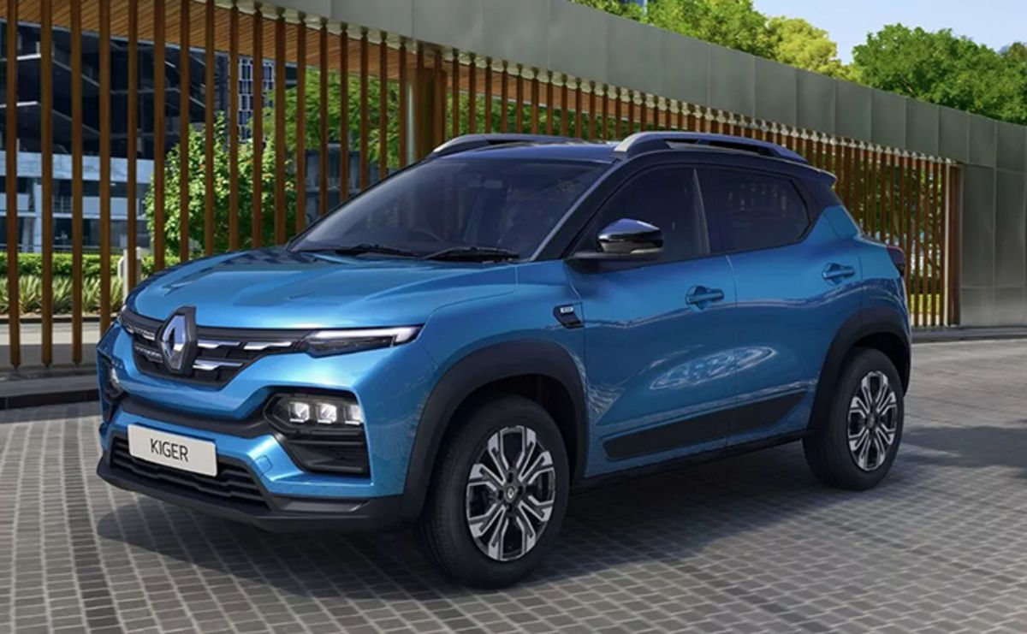

v29.

Model name :- Maruti Suzuki Swift

Company:- Maruti

Price:- ₹ 5.85 Lakh (avg. showroom price )

Mileage:- 23.2 to 23.76 kmpl

Engine:- 1197 cc

Transmission:- Manual & AMT

Fuel Type:- Petrol

Seating Capacity:- 5 Seater

ARAI Mileage:- 23.05 kmpl ( Petrol )

Colours :- White , Red , Blue , Black , Grey

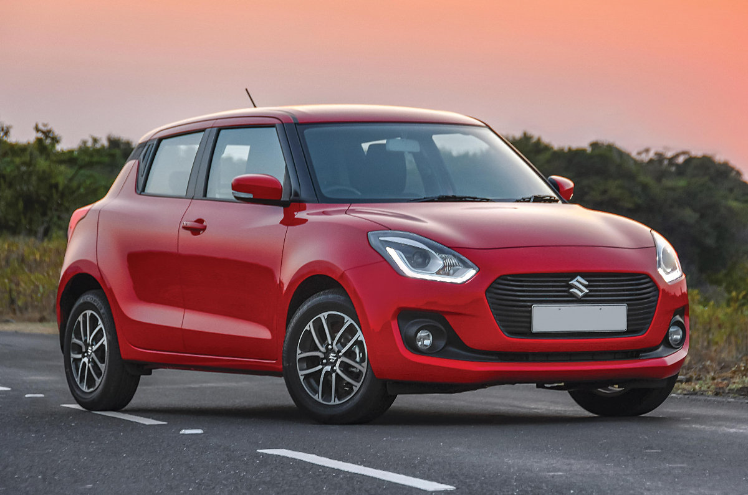

v30.

Model name :- Tata Altroz

Company:- Tata

Price:- ₹ 5.89 Lakh (avg. showroom price )

Mileage:- 19.05 to 25.11 kmpl

Engine:- 1199 to 1497 cc

Transmission:- Manual

Fuel Type:- Petrol & Diesel

Seating Capacity:- 5 Seater

ARAI Mileage:- 25.11 km/kg ( Diesel )

19.05 kmpl ( Petrol )

Colours :- White , Red , Blue , Black , Grey

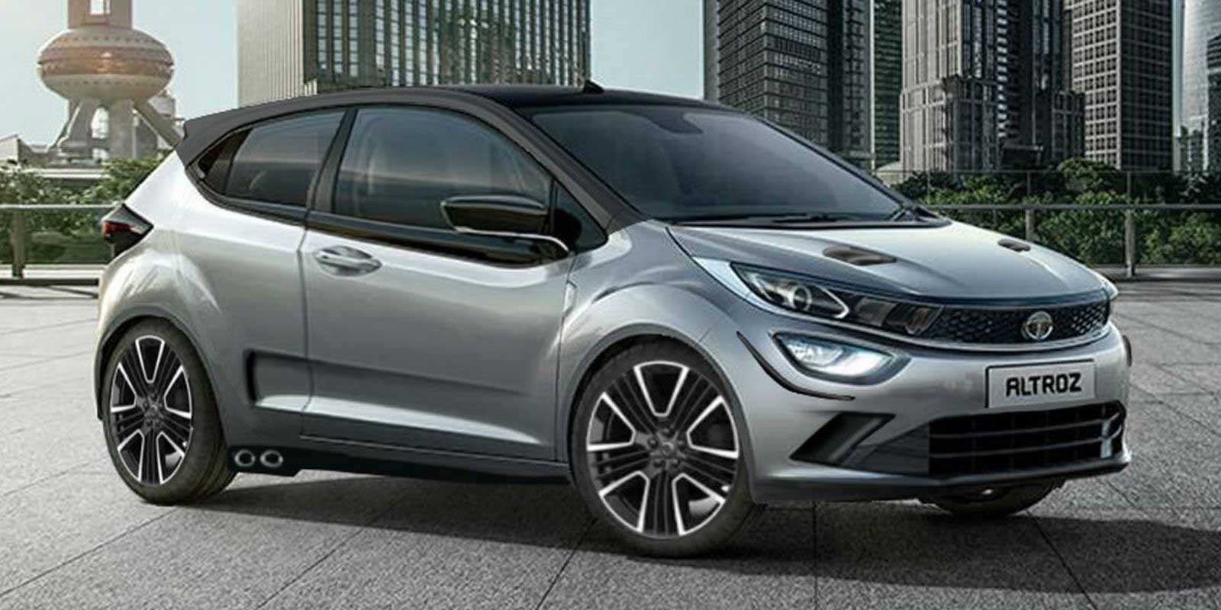

v31.

Model name :- Hyundai Aura

Company:- Hyundai

Price:- ₹ 6.00 Lakh (avg. showroom price )

Mileage:- 20 to 28 kmpl

Engine:- 998 to 1197 cc

Transmission:- Manual & AMT

Fuel Type:- Petrol, CNG

Seating Capacity:- 5 Seater

ARAI Mileage:- 28.00 km/kg ( CNG )

21.00 kmpl ( Petrol )

Colours :- White , Red , Blue , Black , Grey

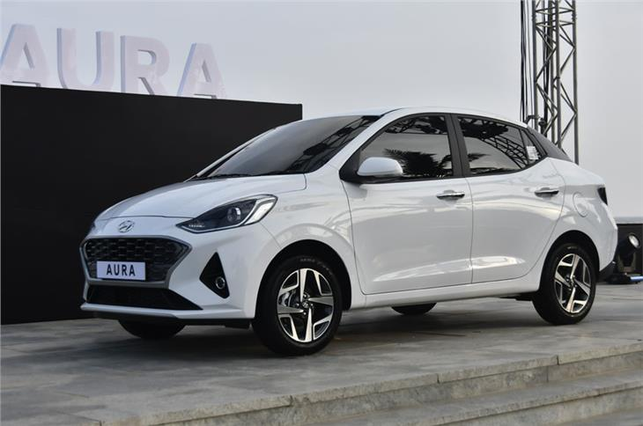

v32.

Model name :- Tata Tiago NRG

Company:- Tata

Price:- ₹ 6.57 Lakh (avg. showroom price )

Mileage:- 20.09 kmpl

Engine:- 1199 cc

Transmission:- Manual & AMT

Fuel Type:- Petrol

Seating Capacity:- 5 Seater

ARAI Mileage:- 22.05 kmpl ( Petrol )

Colours :- White , Red , Blue , Black , Grey

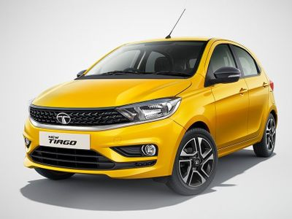

v33.

Model name :- Kia Sonet

Company:- Kia

Price:- ₹ 6.87 Lakh (avg. showroom price )

Mileage:- 18.2 to 24.1 kmpl

Engine:- 998 to 1493 cc

Transmission:- Manual, Clutchless Manual

Fuel Type:- Petrol & Diesel

Seating Capacity:- 5 Seater

ARAI Mileage:- 24.01 km/kg ( Diesel )

10.05 kmpl ( Petrol )

Colours :- White , Red , Blue , Black , Grey

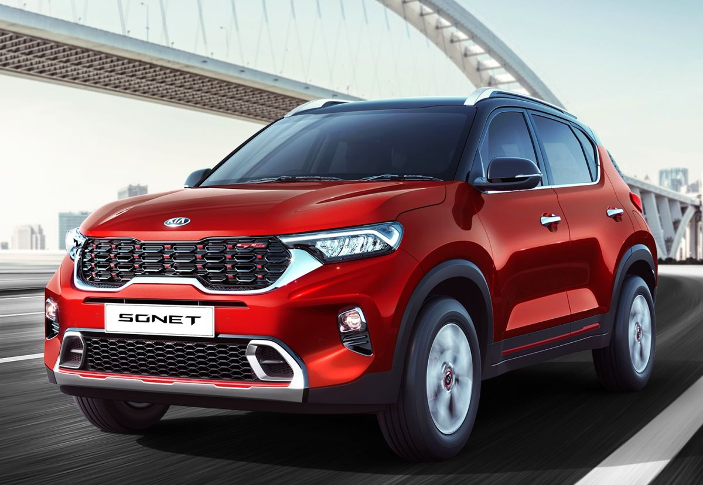

v34.

Model name :- Hyundai i20

Company:- Hyundai

Price:- ₹ 6.91 Lakh (avg. showroom price )

Mileage:- 19.65 to 25.2 kmpl

Engine:- 998 to 1493 cc

Transmission:- Manual, Automatic (CVT), Clutchless Manual & Automatic

Fuel Type:- Petrol & Diesel

Seating Capacity:- 5 Seater

ARAI Mileage:- 25.02 km/kg ( Diesel )

20.35 kmpl ( Petrol )

Colours :- White , Red , Blue , Black , Grey

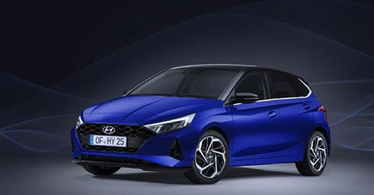

v35.

Model name :- Tata Nexon

Company:- Tata

Price:- ₹ 7.30 Lakh (avg. showroom price )

Mileage:- 16 to 22.4 kmpl

Engine:- 1199 to 1497 cc

Transmission:- Manual & AMT

Fuel Type:- Petrol & Diesel

Seating Capacity:- 5 Seater

ARAI Mileage:- 22.04 km/kg ( Diesel )

17.04 kmpl ( Petrol )

Colours :- White , Red , Blue , Black , Grey

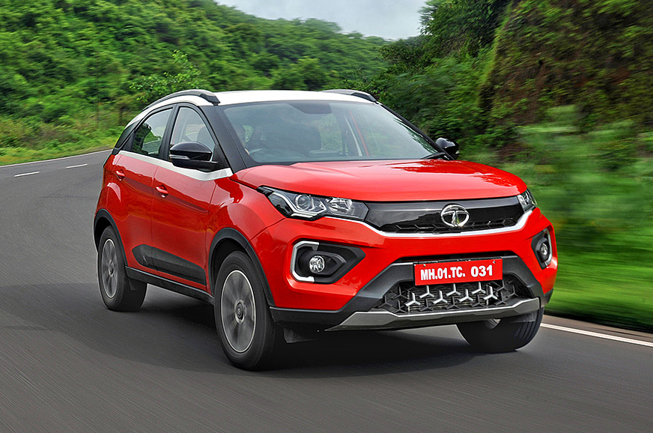

v36.

Model name :- Maruti Suzuki Vitara Brezza

Company:- Maruti

Price:- ₹ 7.61 Lakh (avg. showroom price )

Mileage:- 17.03 to 18.76 kmpl

Engine:- 1462 cc

Transmission:- Manual & Automatic (Torque Converter)

Fuel Type:- Petrol

Seating Capacity:- 5 Seater

ARAI Mileage:- 17.03 kmpl ( Petrol )

Colours :- White , Red , Blue , Black , Grey

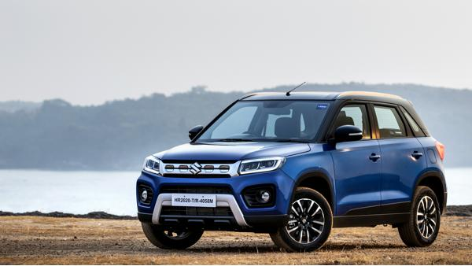

v37.

Model name :- Maruti Suzuki Ertiga

Company:- Maruti

Price:- ₹ 7.96 Lakh (avg. showroom price )

Mileage:- 17.99 to 26.2 km/kg

Engine:- 1462 cc

Transmission:- Manual & Automatic (Torque Converter)

Fuel Type:- Petrol & CNG

Seating Capacity:- 7 Seater

ARAI Mileage:- 26.02 km/kg ( CNG )

19.01 kmpl ( Petrol )

Colours :- White , Red , Blue , Black , Grey

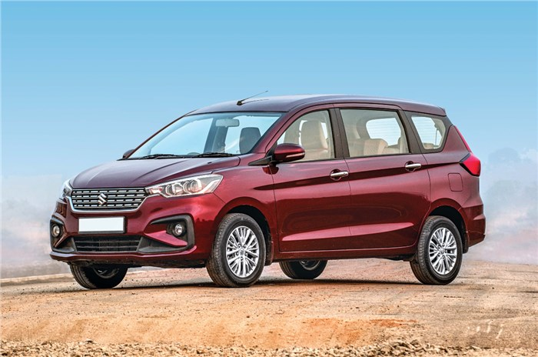

v38.

Model name :- Ford EcoSport

Company:- Ford

Price:- ₹ 8.19 Lakh (avg. showroom price )

Mileage:- 14.7 to 21.7 kmpl

Engine:- 1496 to 1498 cc

Transmission:- Manual & Automatic (Torque Converter)

Fuel Type:- Petrol & Diesel

Seating Capacity:- 5 Seater

ARAI Mileage:- 21.07 km/kg ( Diesel )

15.09 kmpl ( Petrol )

Colours :- White , Red , Blue , Black , Grey

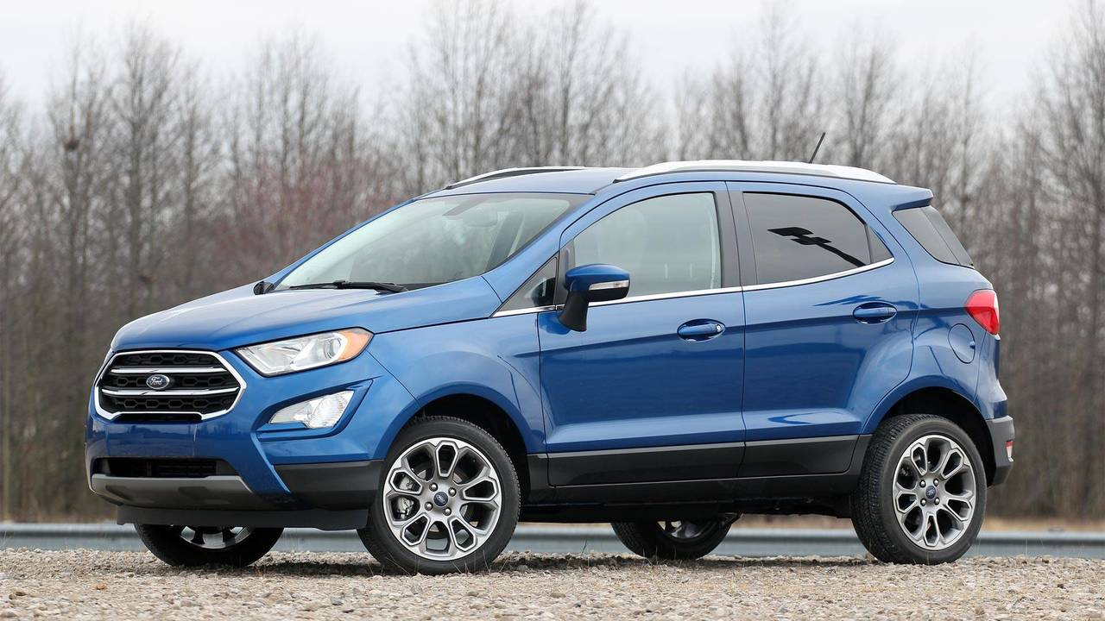

v39.

Model name :- Maruti Suzuki S-Cross

Company:- Maruti

Price:- ₹ 8.51 Lakh (avg. showroom price )

Mileage:- 18.43 to 18.55 kmpl

Engine:- 1462 cc

Transmission:- Manual & Automatic (Torque Converter)

Fuel Type:- Petrol

Seating Capacity:- 5 Seater

ARAI Mileage:- 18.55 kmpl ( Petrol )

Colours :- White , Red , Blue , Black , Grey

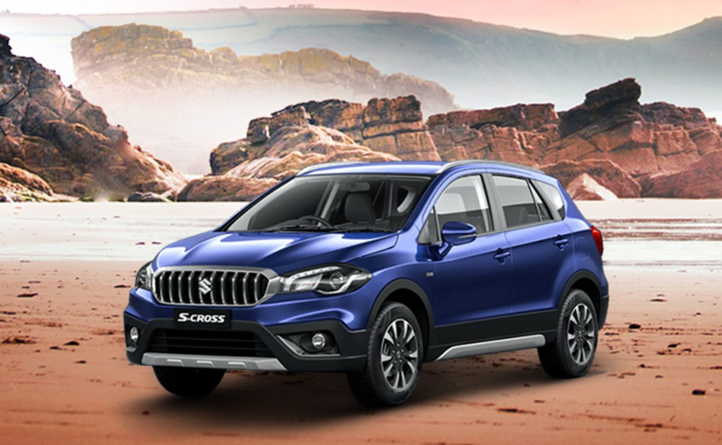

v40.

Model name :- Toyota Urban Cruiser

Company:- Toyota

Price:- ₹ 8.72 Lakh (avg. showroom price )

Mileage:- 17.03 to 18.76 kmpl

Engine:- 1462 cc

Transmission:- Manual & Automatic (Torque Converter)

Fuel Type:- Petrol

Seating Capacity:- 5 Seater

ARAI Mileage:- 17.03 kmpl ( Petrol )

Colours :- White , Red , Blue , Black , Grey

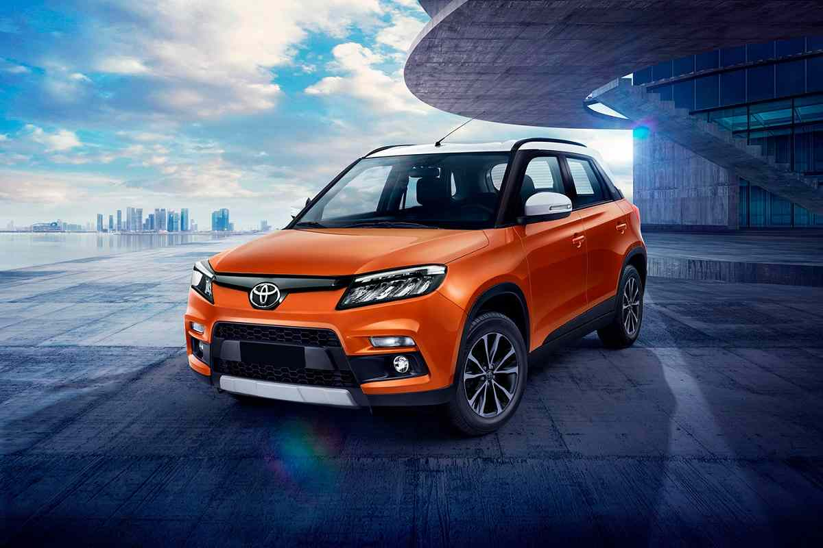

v41.

Model name :- Mahindra Bolero Neo

Company:- Mahindra

Price:- ₹ 8.77 Lakh (avg. showroom price )

Mileage:- 17.29 kmpl

Engine:- 1493 cc

Transmission:- Manual

Fuel Type:- Diesel

Seating Capacity:- 7 Seater

ARAI Mileage:- 17.29 km/kg ( Diesel )

Colours :- White , Red , Blue , Black , Grey

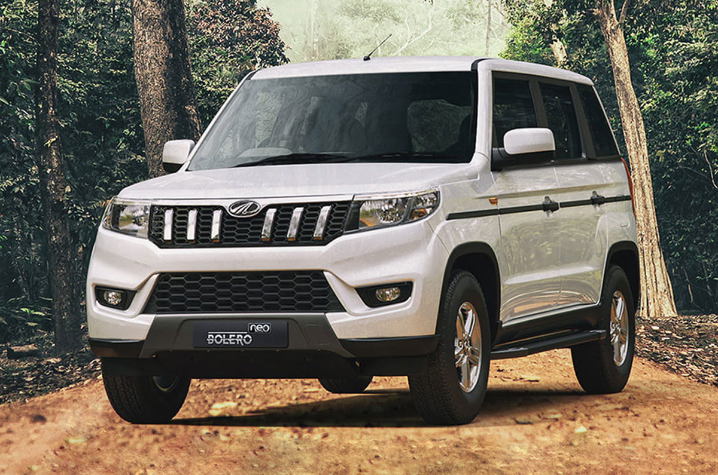

v42.

Model name :- Hyundai Verna

Company:- Hyundai

Price:- ₹ 9.28 Lakh (avg. showroom price )

Mileage:- 17.7 to 25 kmpl

Engine:- 998 to 1497 cc

Transmission:- Manual, Automatic (CVT), Automatic (Torque Converter)

Fuel Type:- Petrol & Diesel

ARAI Mileage:- 22.00 km/kg ( Diesel )

17.07 kmpl ( Petrol )

Colours :- White , Blue , Black , Grey

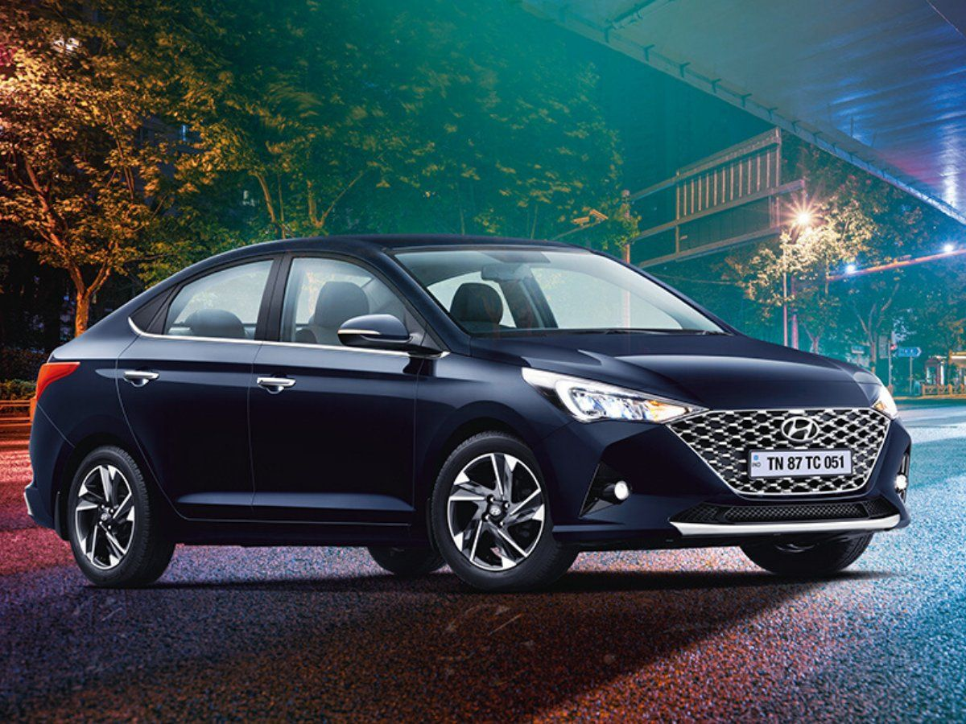

v43.

Model name :- Kia Seltos

Company:- Kia

Price:- ₹ 9.95 Lakh (avg. showroom price )

Mileage:- 16.1 to 20.86 kmpl

Engine:- 1353 to 1497 cc

Transmission:- Manual, Clutchless Manual, Automatic

Fuel Type:- Petrol & Diesel

Seating Capacity:- 5 Seater

ARAI Mileage:- 20.87 km/kg ( Diesel )

16.05 kmpl ( Petrol )

Colours :- White , Red , Blue , Black , Grey

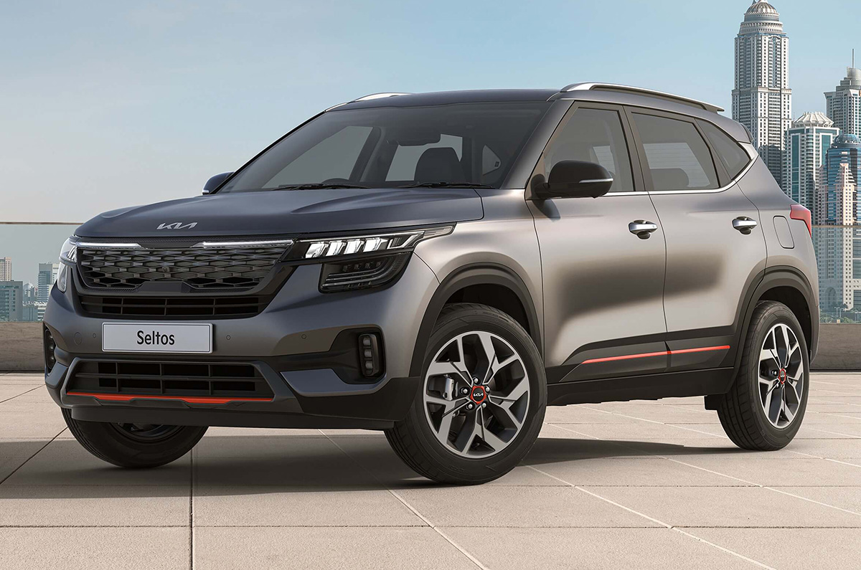

v44.

Model name :- Volkswagen Vento

Company:- Volkswagen

Price:- ₹ 10.00 Lakh (avg. showroom price )

Mileage:- 16.35 to 17.69 kmpl

Engine:- 999 cc

Transmission:- Manual & Automatic (Torque Converter)

Fuel Type:- Petrol

Seating Capacity:- 5 Seater

ARAI Mileage:- 17.69 kmpl ( Petrol )

Colours :- White , Red , Blue , Black , Grey

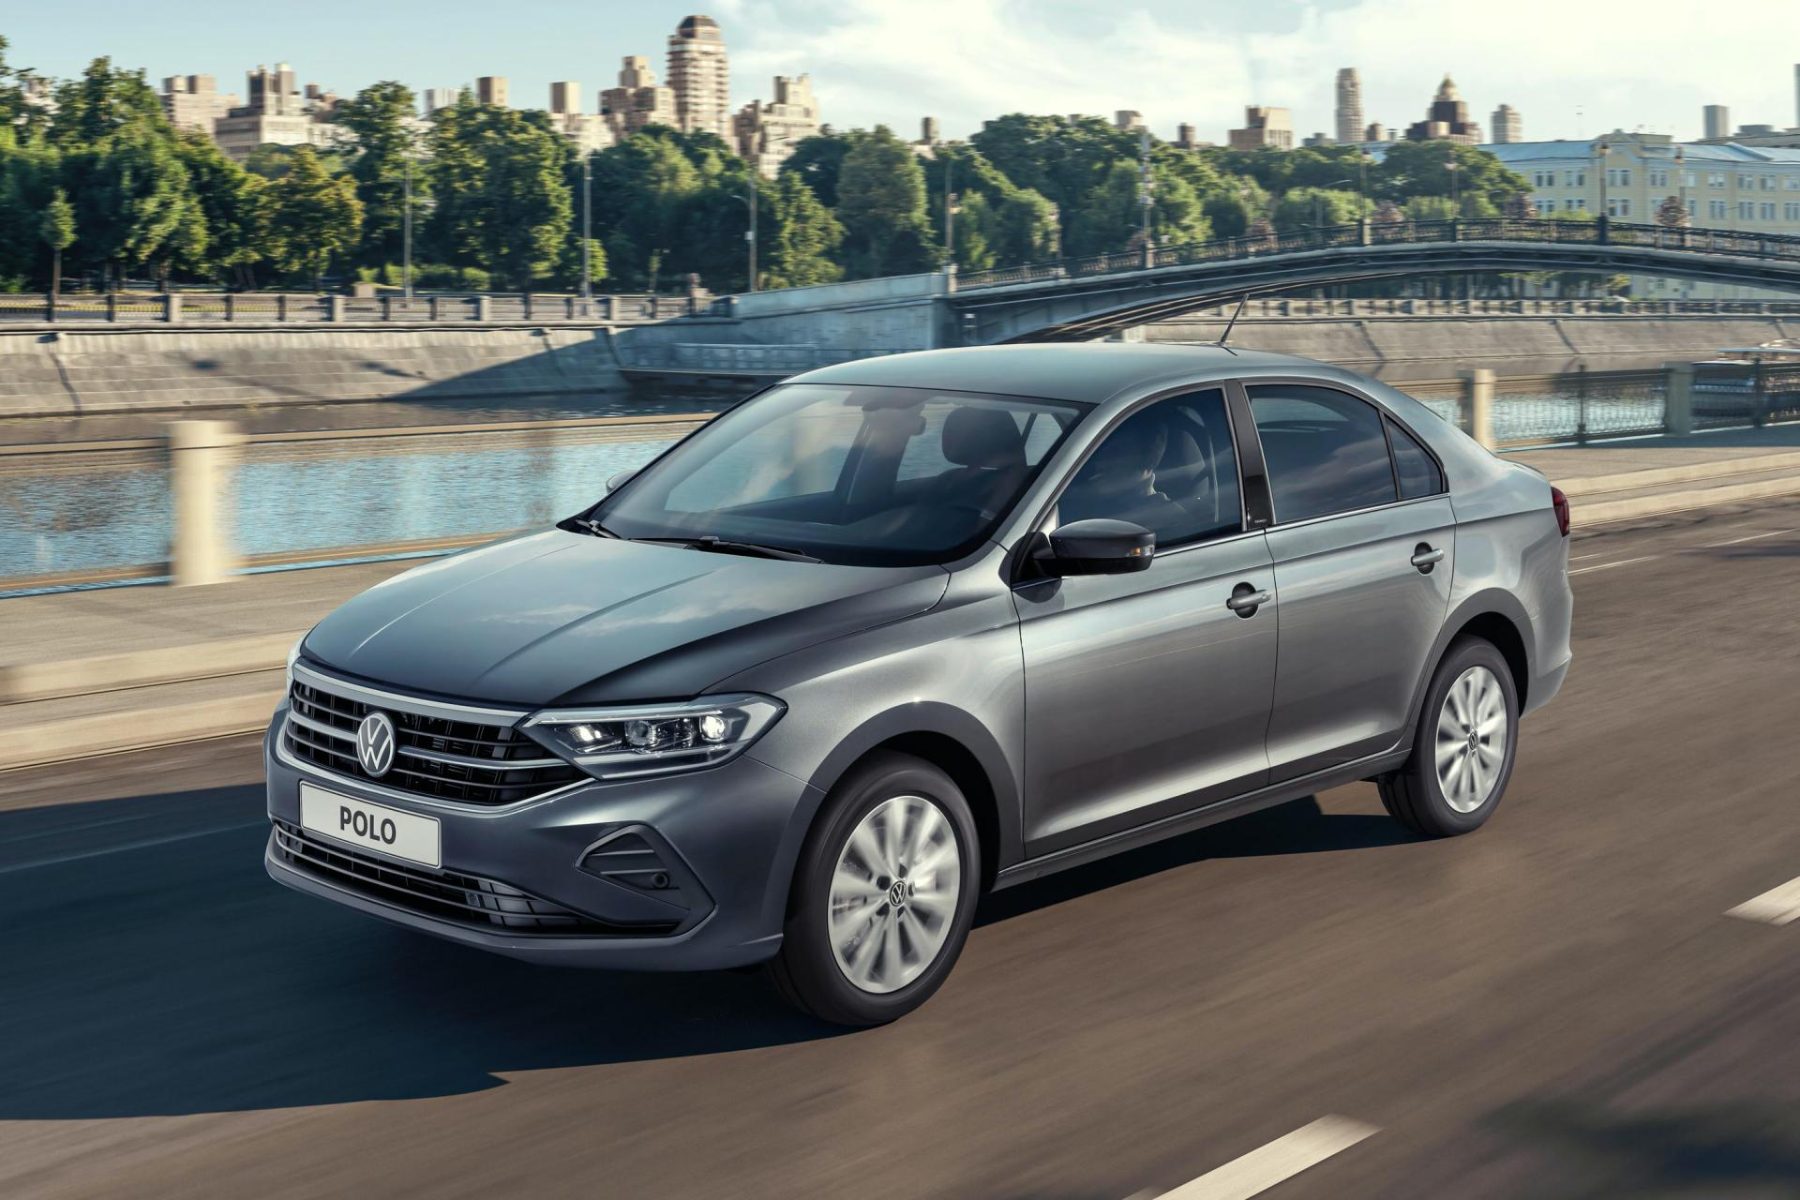

v45.

Model name :- Honda All New City

Company:- Honda

Price:- ₹ 11.19 Lakh (avg. showroom price )

Mileage:- 17.8 to 24.1 kmpl

Engine:- 1498 cc

Transmission:- Manual & Automatic (CVT)

Fuel Type:- Petrol & Diesel

Seating Capacity:- 5 Seater

ARAI Mileage:- 24.01 km/kg ( Diesel )

17.04 kmpl ( Petrol )

Colours :- White , Red , Blue , Black , Grey

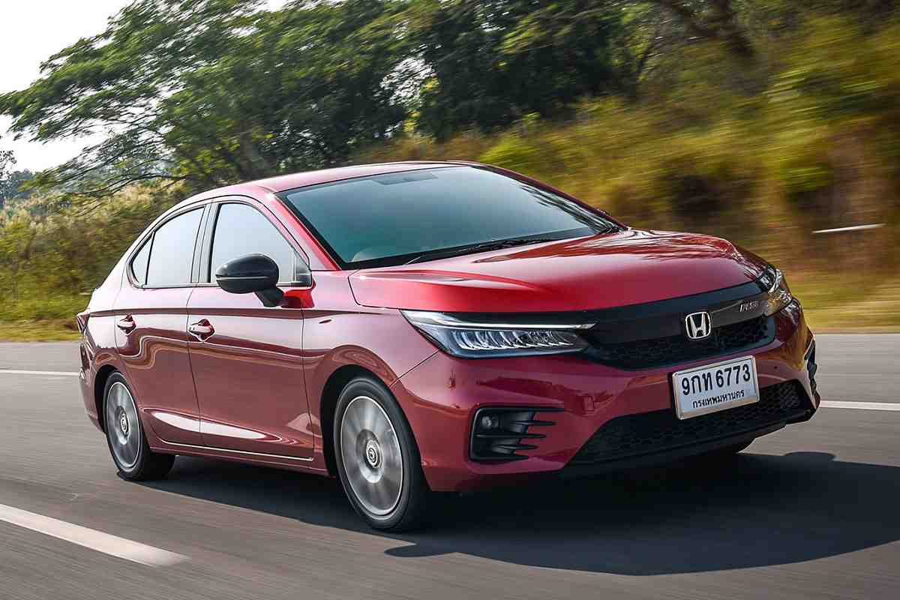

v46.

Model name :- Tata Tigor EV

Company:- Tata

Price:- ₹ 11.99 Lakh (avg. showroom price )

Transmission:- Automatic

Fuel Type:- Electric

Seating Capacity:- 5 Seater

Max Power:- 73.75bhp

Battery Capacity:- 26 kWh

Charging Time:- 1 h

Colours :- Blue , Black , Grey

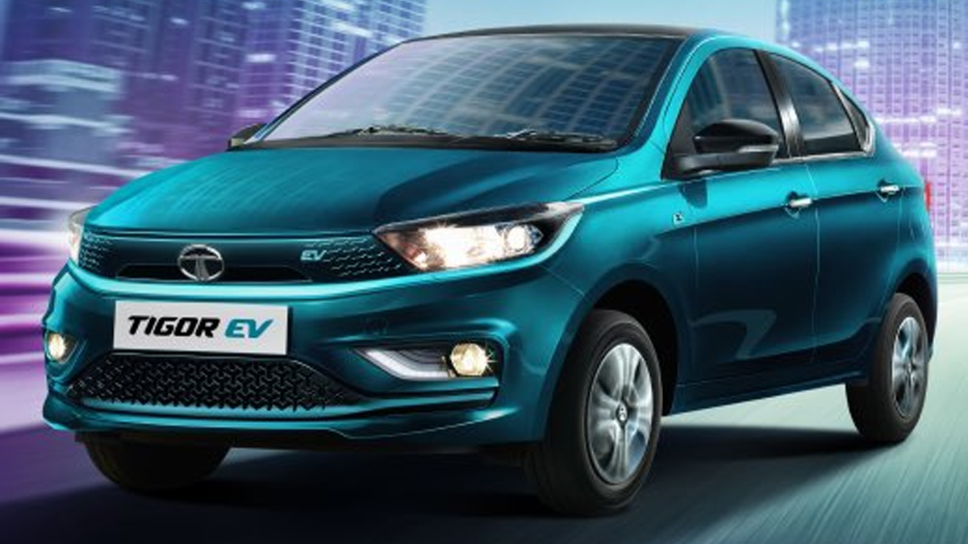

v47.

Model name :- Mahindra XUV700

Company:- Mahindra

Price:- ₹ 12.49 Lakh (avg. showroom price )

Engine:- 1997 to 2184 cc

Transmission:- Manual & Automatic (Torque Converter)

Fuel Type:- Petrol & Diesel

Seating Capacity:- 5 & 7 Seater

ARAI Mileage:- 20.04 km/kg ( Diesel )

14.02 kmpl ( Petrol )

Colours :- White , Red , Blue , Black , Grey

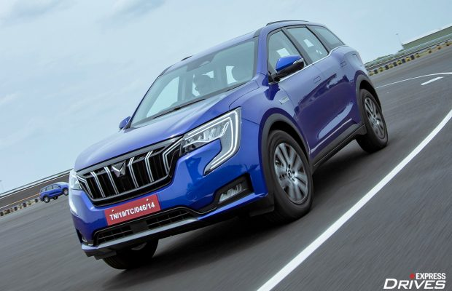

v48.

Model name :- MG Hector

Company:- MG

Price:- ₹ 13.50 Lakh (avg. showroom price )

Mileage:- 13.96 to 17.41 kmpl

Engine:- 1451 to 1956 cc

Transmission:- Manual, Automatic (CVT) & Automatic (Dual Clutch)

Fuel Type:- Petrol, Diesel & Hybrid (Electric + Petrol)

Seating Capacity:- 5 Seater

ARAI Mileage:- 17.41 km/kg ( Diesel )

14.16 kmpl ( Petrol )

15.81 kmpl ( Hybrid (Electric + Petrol) )

Colours :- White , Red , Blue , Black , Grey

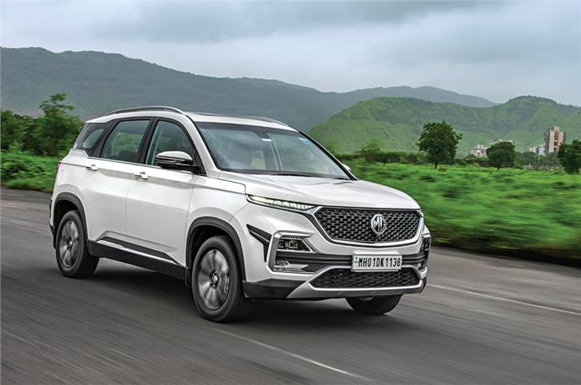

v49.

Model name :- Tata Nexon EV

Company:- Tata

Price:- ₹ 14.24 Lakh (avg. showroom price )

Transmission:- Automatic

Fuel Type:- Electric

Seating Capacity:- 5 Seater

Max Power:- 127bhp

Battery Capacity:- 30.2 kWh

Charging Time :- 1hr

Colours :- White , Blue , Black

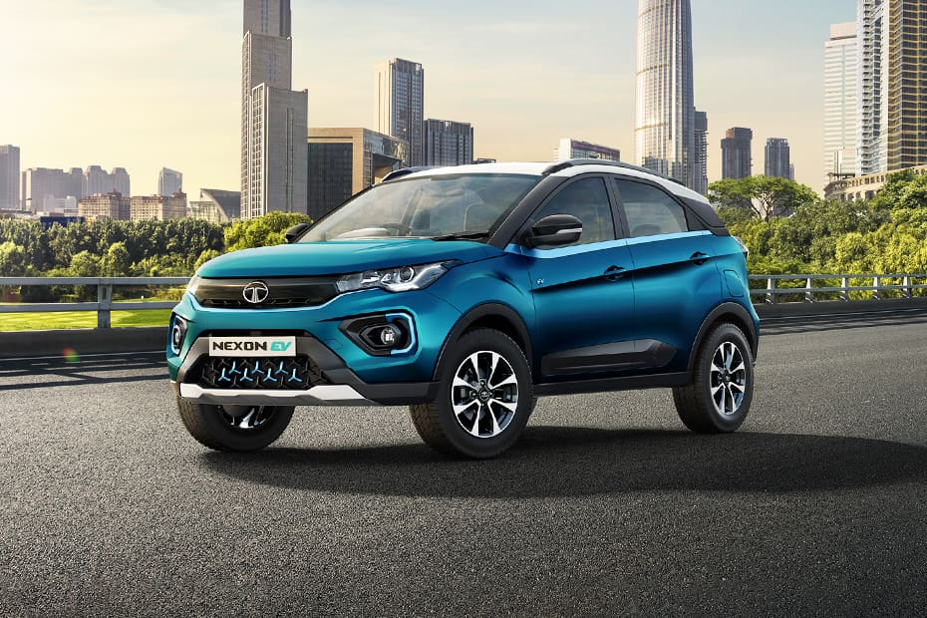

v50.

Model name :- Tata Safari

Company:- Tata

Price:- ₹ 15.00 Lakh (avg. showroom price )

Mileage:- 14.08 to 16.14 kmpl

Engine:- 1956 cc

Transmission:- Manual & Automatic (Torque Converter)

Fuel Type:- Diesel

Seating Capacity:- 6 & 7 Seater

ARAI Mileage:- 16.14 km/kg ( Diesel )

Colours :- White , Red , Blue , Black , Grey

